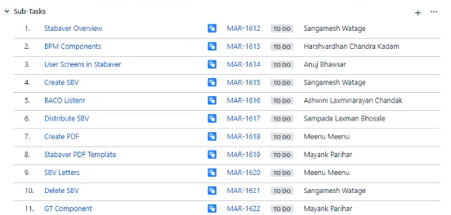

Overview

STABAVER : here Generating pdf -> for the requested bank statement by customer/corporate client. ->So bank charges for providing those statement with info as (Prologue ,Chapters and Epilogue).

SBV (Standard bank verkling) -> Dutch version

SBC (Standard bank confirmation) -> English version

Request for statement can be made using :

1. Internet banking
2. Visiting bank

So SBV is generated for a Client (Corporate Client/Normal customer ) .

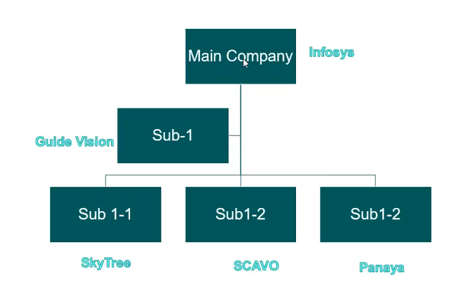

There will be a main company and its sub company so there will be unique BC number (Business contact number) for each.

So main company can request for SBV for itself(Main BC number) and its child company(Related BC number) as per the hierarchy.

SBV will have information such as Collateral/loans/guaranties that the client is having.

So bank holds all these data in different data sources/database:

ACBS: Account related data.

BCDB:

Credit Store:

So for SBV we will go to all these related master data source and collect required data and make its XML and then make its pdf (by ECM team) in ABN AMRO’s template of providing statement.

So ECM service helps in creating that pdf.

>Smartflow case : whenever client/operations guy request for SBV statement internally its referred as case here.

Data needed to raise Request for SBV will be : for example ->Main BC, Related BC’s , preferred language.

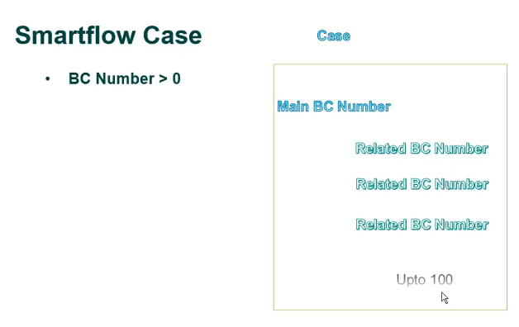 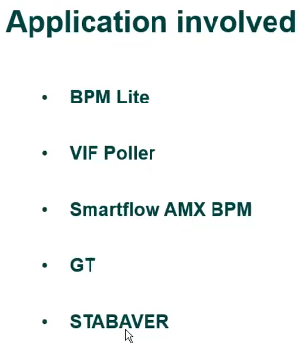

Also

* BACO
* IBM MQs(to connect BACO and STABAVER with Input MQ to receive request from SBV to BACO and Output MQ to give response from BACO to SBV)

BPM lite is iProcess application.

VIF poller is a database.

Smartflow is a BPM application.

GT is a tariffing system in ABN AMRO for BCs for charging amount.

Stabaver is in which pdf is created for BC.

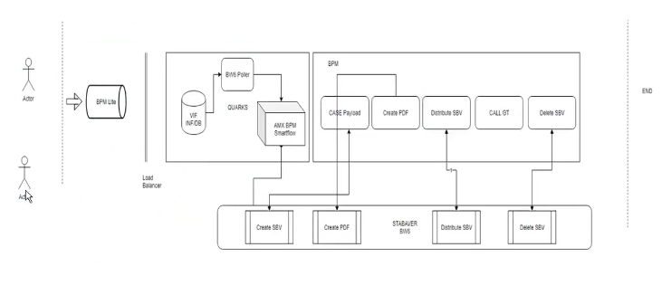

Here Actors are (client itself/operations guy) who are requesting for SBV.

1. They will need to fill the form with request parameters like BC numbers ,preferred language,address,country….
2. So this request is collected and stored as back base form.
3. Then the request comes to BPM lite.
4. And so on its stored in VIF database.
5. So using bw6 poller as per the date for which SBV is requested Smartflow AMX bpm will create case and case id for the request and will create dossier and add the request data to dossier as initial data.
6. So once the case is created it is published to stabaver .
7. And Create SBV interface is invoked from smartflow by providing form id, case id and dossier id. And so the processing to fetch data is started ,So by this info XML is created by fetching data from various data source. And so on XML is created. And so on pdf if generated and distributed.
8. BACO is used to get the data .BACO gets data from ACBS and stores it into DB2 database,and this is done every month so the data present in BACO is present for end of previous month.
9. Mainly two sources are called for SBV data BACO (for Non Credit data ex:accounts,gaurrenties i.e nearly 90 % ) and Credit store(remaining 10 % for Credit data ex : loans,facilities, collaterals).
10. So as if fr example in our request for SBV we have 1 main BC and 3 related BCs for a case so total 4 requests will be sent to BACO for separate BCs ,So now BACO gives in response raw data for all the BCs and we create XML for all of them.
11. So now these XML data is updated in a payload on BPM side, as the payload is updated now the request will go to next component/service to create pdf.
12. Once the create PDF is done for all the BCs response goes to BPM.
13. Now the distribute pdf component sends this pdf to operations team by mail.Now the operations team member takes print of it and manually sends the SBV to customer by courier.
14. It would take 1 or 2 days or whatever So there would be some wait time after that Call GT component in BPM is called to calculate the amount that needs to be charge to customer for providing SBV pdf.

[Note : As fr above example in our request for SBV we have 1 main BC and 3 related BCs so we will not charge for all 4 BCs we will just charge the Main BC using Call GT component.]

1. So after providing the charges for SBV after some wait time (wait time here is for if customer faces any issues in statement or some modifications are required ...etc So the changes will be done by operations and again the flow will go as per the norms).
2. So once the case is closed Delete SBV component will be called .
3. This wait time after sending SBV to customer and before Deleting case is called user screen 4 (Wait for closing the case)

BPM COMPONENTS

Using Tibco AMX BPM we create components for Smartflow.

Smartflow.bpm project has the main process named as Flowprocess for our BPM component.

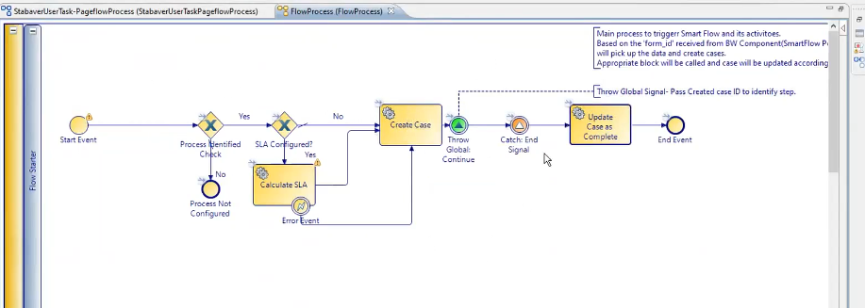

This flow will create the case for the request with main case id by which the case will be identified throughout the lifetime of process.

In this flow what is SLA for which condition is being checked weather its configured or not ?

And what kind of task is this Create Case Task which is of type Global Data Operations?

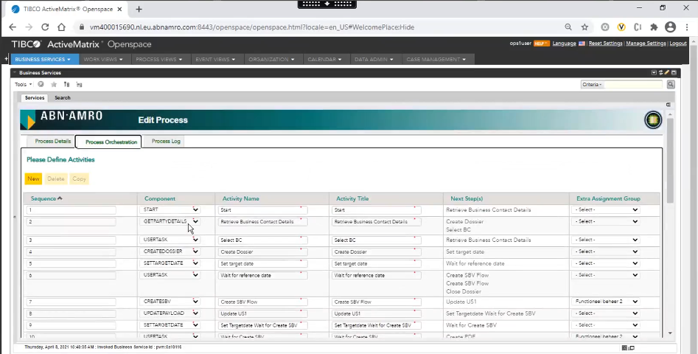

So the components created in Tibco AMX BPM is used here in Smartflow BPM as required by operations team.

For example here:

1. The Start component creates the case for the request coming from back base form.
2. GetPartyDetails will get the details for respective BC number.

And so on each component has its own Functionality.

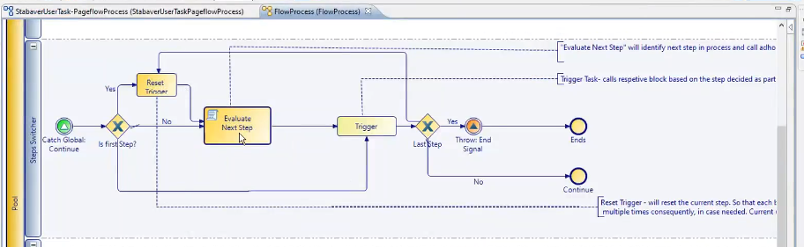

So this is the loop by which next step/component for the Smartflow process is evaluated. 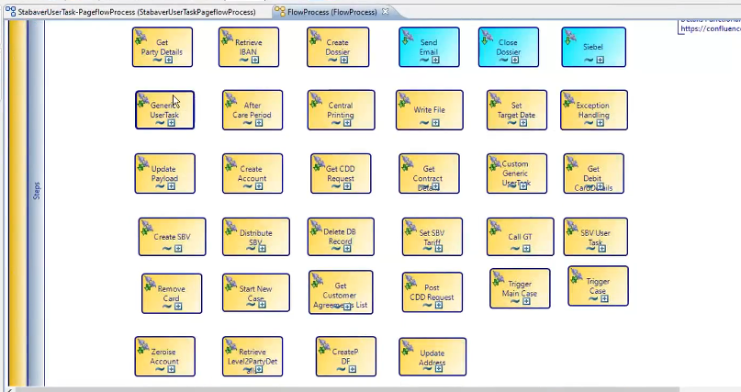

These are the components created in amx bpm and BW so can be used in smartflow.

How are these subprocess for component is configured and called ?

* So the activity 3 is created by Marina team and it also uses generic tariffing bom for GT component.

So in activity 3:

1. Create SBV Component:

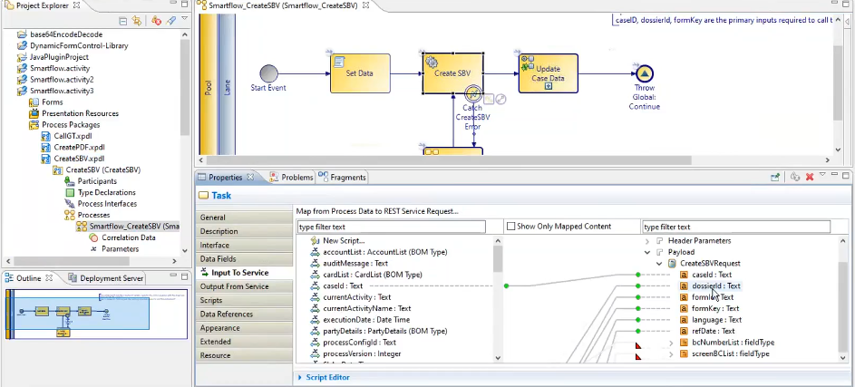

In this component for 1 pallet i.e Set Data we fetch data from globalCaseData payload and we set data field values in its script in local process variables with globalCaseData values that are required as input parameter for our create SBV service call i.e the next pallet.

Now the 2nd pallet is calling BW createSBV service.

So there will be some waitTime since bw service is being called so the data that is returned depends on the BACO batches and other data source.

So as per the response from from BW service the data is updated in globalCaseData payload as per 4th pallet .

Now in 3rd pallet is for retrying the create SBV service call if due to some reason its unable to fetch data from the datasource or is stuck at some point.

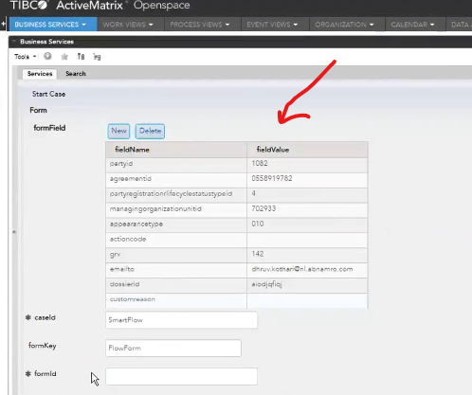

This is the globalCaseData or payload i.e the name value pair.

Initially it will have mandatory values required for service and as per the execution of each step the globalCaseData gets updated with the response of service.

So for testing case can be raised using openspace ->Startcase with the mandatory fields for the Service that we are calling here for CreateSBV inputs are BCnumber list, dossier id, case id …. Etc etc.

But in real case scenario case is raised using Backbase form by customer/operation member.

* So the same process is for CreatePDF and DistributeSBV components.

1. So similarly for CallGT component we have setData pallet but here we don’t have our BW service we are calling GT component API from GT team.

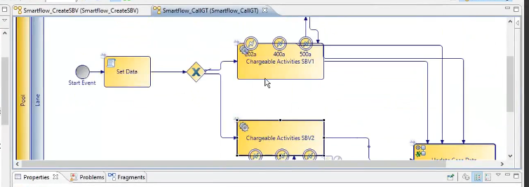

Here we have condition based call depending weather the price that is to be charged is fixed or variable.

1. Stabaver User Task (User screen 3) : for broken reference date.

* Since BACO returns statement for last month end so if the reference date provided is mid of the month so this case comes to US3.
* So in US3 we create a form to show data to operations team so that they can add weather the customer has any pending loans or other details that needs to be added in SBV for this period that are not reflected by BACO response this is done in US3.
* Mainly this screen provides Operation member to edit details received from BACO for respective BC numbers.
* There can also be a case when SBV is sent to customer from operations team and customer has a specific time in which they can come if found any issue in their statement so this screen can be used for editing the respective data in SBV for the customer.

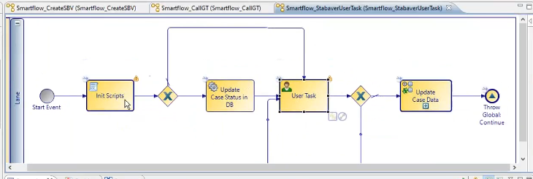

Here also in US3 task is similar at higher level Init Scripts for fetching data ,UserTask here is not calling any BW service but itself providing a screen for editing the retrieved input data i.e the SBV XML from Init Scripts and then after the changes are made the flow go to update them in Initial Payload.

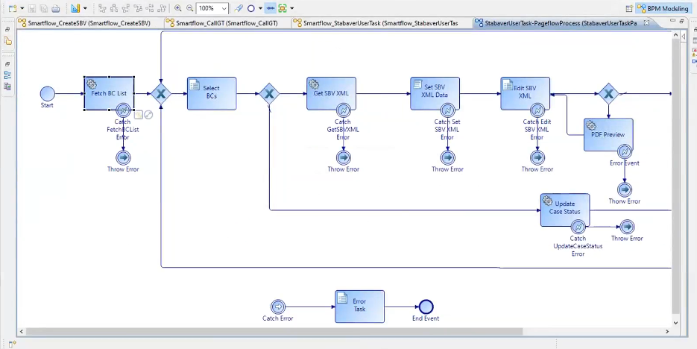

Inside user task :

We have some BW service calls present with name XMLManagement on BW side.

Here in US3 we have a maker checker pair for operations team i.e if some fields have been added in US3 for respective BC number in global data payload so that will now be forwarded to corresponding colleague of other than the one who made changes for review, So now he has option to Approve or reject the changes.

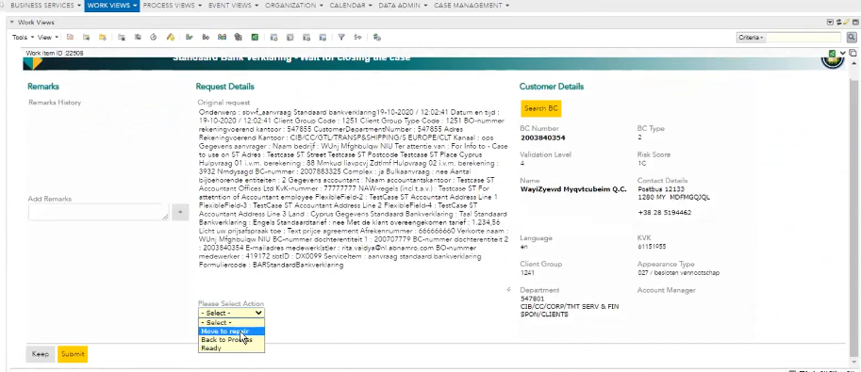

* This wait time after sending SBV to customer and before Deleting case is called user screen 4 (Wait for closing the case).

So we have options here as :

1. Move to repair : this will take requester to US3.
2. Back to process : will restart whole case. i.e create SBV onwards.
3. Read : will close the case.

* User Screen 1 (Result Create SBV) is the screen that comes into picture when BC number provided in the back base form is not valid. So here in this screen we have option to re enter BC or we can exit.
* User Screen 2 (Technical errors create SBV) is the screen when BC number is correct but there is some issue from BACO side example : BACO is down etc etc.
* Smartflow.bom is used by Smartflow team so if we add any new bom or make any changes in service descriptor Smartflow.bom of so would need to inform them before deployment.
* As the wsdl files (SOAP APIS) are imported in smartflow.bom’s service descriptors folder so its bom is created by BPM by default.

User Screens In SBV

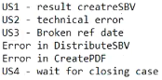

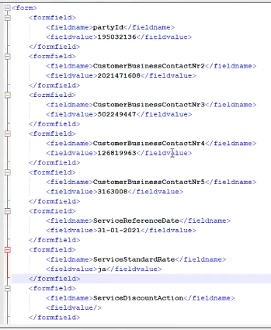

So case in SBV can be raised using XML :

* The above fields : partyId(Main BC), related BCs ,ServiceReferenceDate ,Service Standard rate ,Service Discount Action are the mandatory fields for raising case.
* So as the case is raised using XML it would take some time to be reflected on respective openspace.

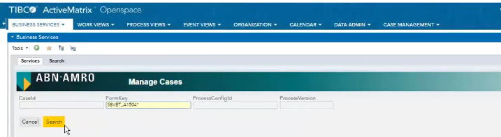

* So we can open raised case in openspace/DB and monitor its progress.
* Error in distribute SBV and Error in Create Pdf both are technical error only but the only difference in both is Technical errors create SBV come before fetching data from BACO but these errors are occurred at later stage so we don’t need to wait for BACO batches if retriggering case here.
* Error in distribute SBV:
* Error in Create Pdf:

Create SBV and Baco Listener (BW)

What is the starting point in BW side for SBV and what is the overall flow from Create SBV till Closing of case ???

* SBV has Main 2 parts :

1. CreateSBV – Here data is requested and received from BACO and stored in Dossier.

[i.e LEG1(requesting data from BACO) and LEG2(receiving data from BACO) ]

Means generating XML and storing into dossier

1. Distribute SBV – here the above generated XML is converted to PDF.

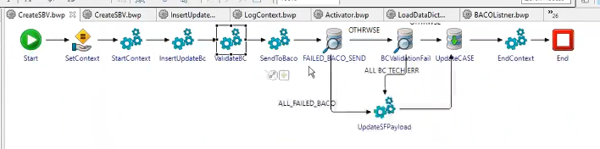

this is the initial step in BW that invokes BW service for Create SBV.

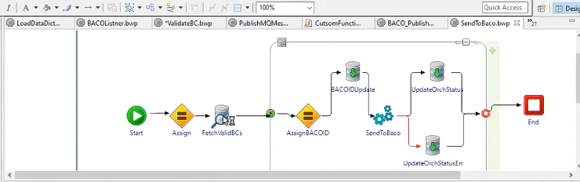

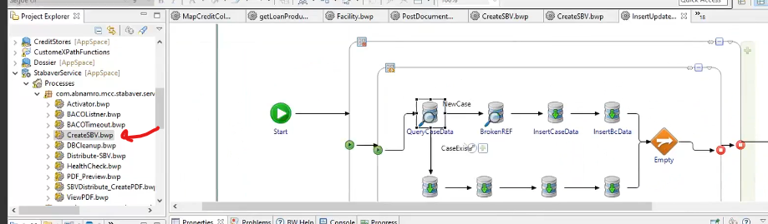

Data is fetched from BACO, Credit Store and BCDB data sources.

BCDB : is used for fetching data such as Prologue data i.e Client Information , Author information.

Credit Store : All 7 chapters data .Ex: facilities , loans , Collaterals, Accounts

BACO : All 7 chapters data

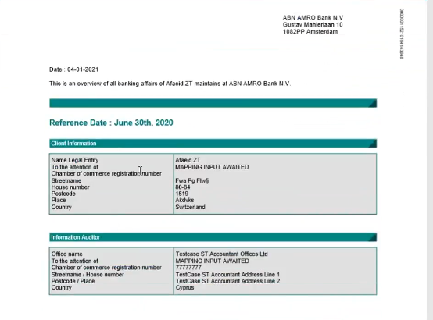

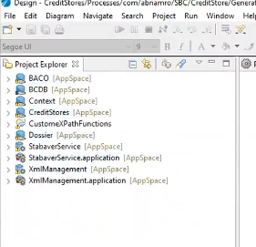

these are BW marina components.

So initially in BW prologue data (Client and Author information) is collected from BCDB

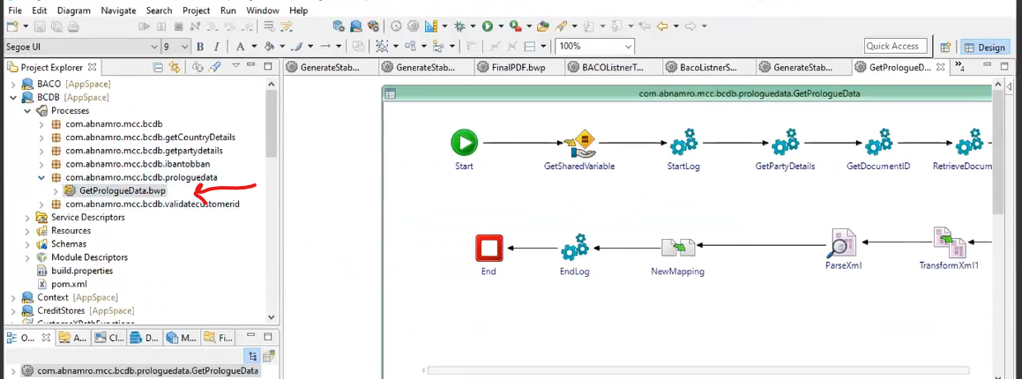

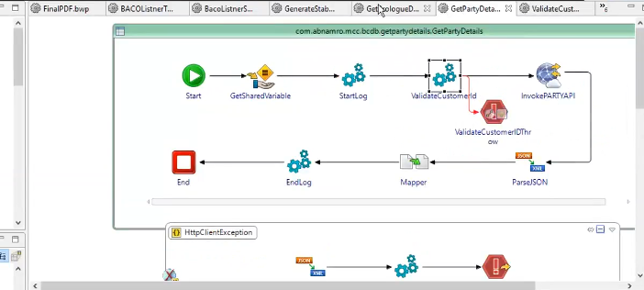

Flow Orchestration table informs about the component in which case is at the moment.

There are total 3 LEGs -> LEG1 , LEG2 and LEG3.

So the data sent to BACO for requesting account details comes under LEG1 : till Create SBV.

LEG2 is : till Distribute SBV

LEG3 is : till Closing the SBV Case

Input for BACO to get case info are : BC number ,BACO request id,reference date and language(EN/Dutch).

CreditFacility

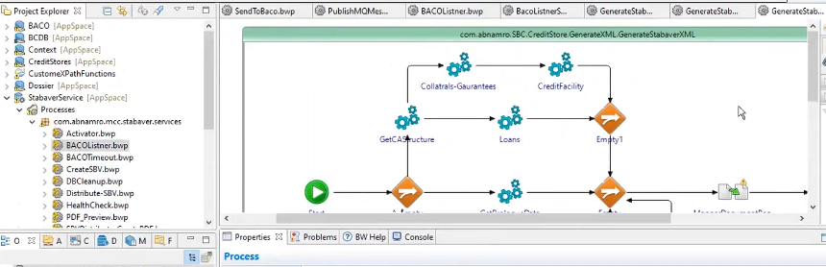

Here we are fetching data from Credit Agreement Structure API which uses Input as BCnumber and reference date.

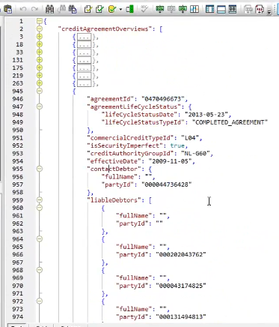

So this is the response that we get here from Credit Agreement Structure API having overview info of loans and facility.

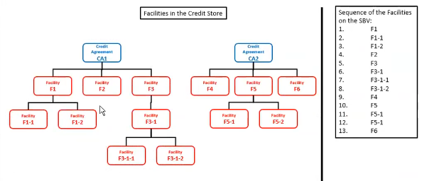

So this is the order/sequence in which Facilities and their child Facilities be displayed in SBV .

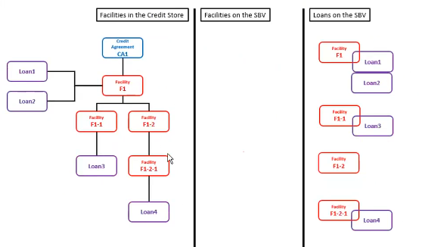

So if Facilities or its any child have No loans it will come under *Facilities on the SBV* section and if facility or its any child has Loan it comes under *Loans on SBV* section.

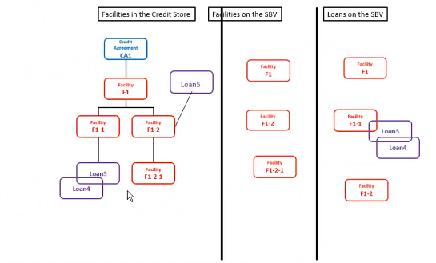

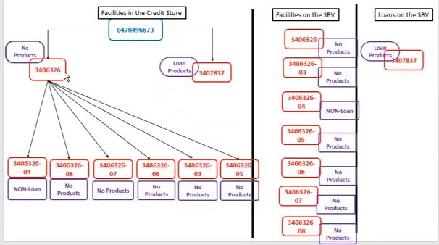

So, there are many more graph and ***sequence of*** ***facility and loans*** (Need this PDF) like this …

43:50 -> sampada ->12 April

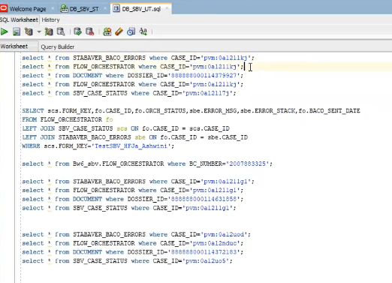

Some Important queries

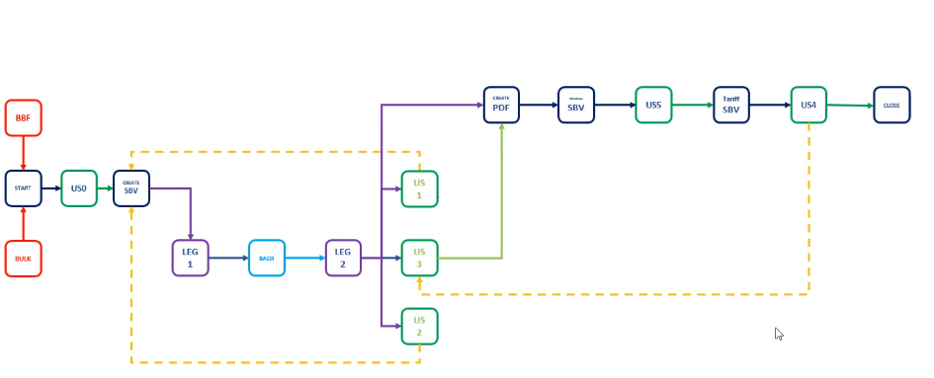

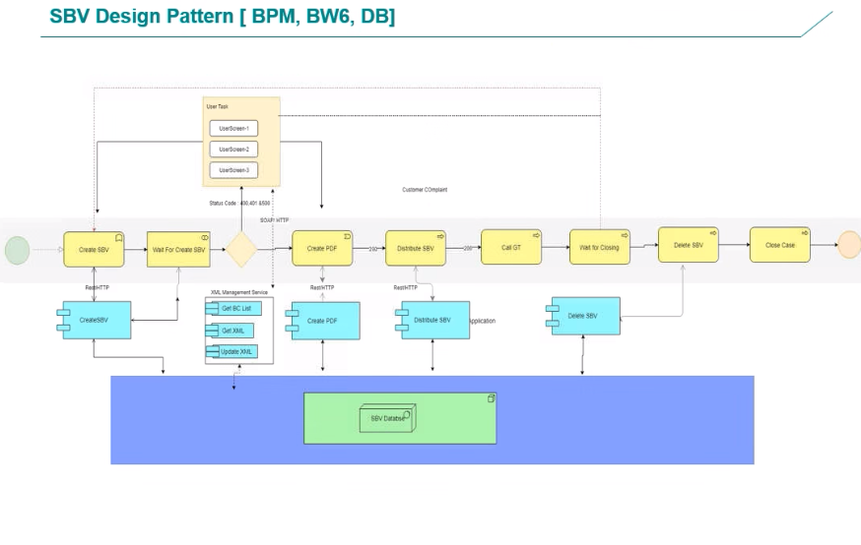

PR Support

Case_status table will have all the case entries:

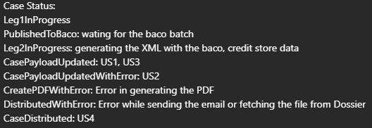

Error in GT component will also show case distributed.

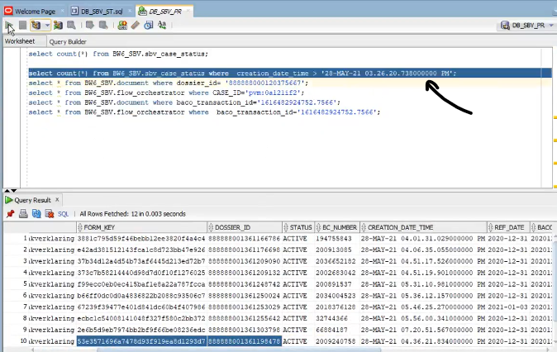

So we can also do it by filtering by timestamp after last successful case.

Errored cases will be needed to retriggered manually.

Case in orchestrater table orch status will be as Initial_Insert for incorrect BCnumber.

If there is any error in process while creating PDF or XML then orch status will be Process_error

In document table ECM_XML column is for storing xml for changes in US3.

Document _id is used to call dossierAPI in postman if dossier is failing at any phase.

Case Status is the main table here we will get case status as higher level but for which BC our case is stuck we get to know it in Document table.